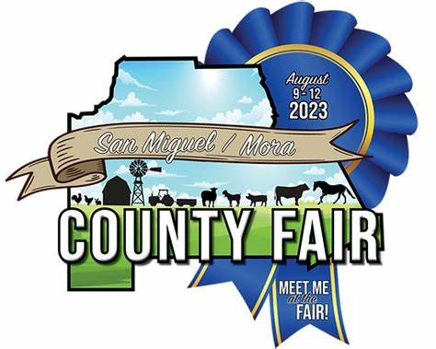REGISTRATION FORM TEAM NAME: ___________________________________________________________________________ Address: _________________________________ City: ________________ Zip: ___________ Phone: ___________________________________ Email: ___________________________________ Captain: __________________________________ Player 2: __________________________________ Player 3: __________________________________ Player 4: __________________________________ Player 5: __________________________________ Player 6: __________________________________ Alt. 1 (optional): ____________________________ Alt. 2 (optional): ____________________________

MUD VOLLEYBALL PARTICIPANT RELEASE AND WAIVER OF LIABILITY I, ______________________________, as well as for my heirs, executors, administrators, agents, successors, representatives and assigns, do hereby fully release, acquit and forever discharge the San Miguel/ Mora County Fair, Inc. and all its Committee members, the City of Las Vegas, the San Miguel/ Mora County Fair Association, all sponsors, volunteers, officials, organizers, and any and all of their employees, agents, servants, representatives, officers, directors, shareholders, administrators, successors, members, partners, insurers, reinsurers, heirs, successors, executors, and assigns or any person or entity connected with any of them, from any and all liability, damages, rights, claims, causes of action, complaints, rights, suits, demands, administrative actions, expenses, costs, fines, claims of injury, attorney or legal fees, expenses, judgments, verdicts, or awards, penalties and/or losses of any kind and nature whatsoever, whether known or unknown, whether choate or inchoate, whether foreseeable or not, including but not limited to the negligence, breach of contract or other wrongful conduct of the parties hereby released, whether in tort or contract, and whether in law or in equity, which I have or may in the future have as a result of injuries or damages sustained, suffered or incurred by me, or any minor child I am responsible for, arising from participation in the MUD VOLLEYBALL tournament/games/event, including but not limited to the actual game itself, and any and all pre or post game activities. In addition, I fully assume all risks for myself and any minor child I am responsible for, that could or may occur as a result of participating in this tournament/games/event. I certify that I have physically prepared myself and/or my child with an adequate level of fitness to participate in the MUD VOLLEYBALL tournament/games/event taking place on August 12th, 2023. I also understand that during this event, participants may be photographed and/or video recorded. This material may then be published in print, online, to social media, and in promotional materials and may also include the participant’s name and biographical information. I hereby permit the capture, publication, and sharing of my and/or my child’s likeness and identifying information in connection to San Miguel/ Mora County Fair. The UNDERSIGNED WARRANTS and ACKNOWLEDGES that he/she has read this MUD VOLLEYBALL PARTICIPANT RELEASE AND WAIVER OF LIABILITY completely and in its entirety, and that by signing it, that he/she fully understands the terms of this MUD VOLLEYBALL PARTICIPANT RELEASE AND WAIVER OF LIABILITY and that he/she voluntarily accepts the terms contained herein and agrees to be bound thereby. TEAM INFORMATION Printed Team Name: ___________________________________________________________________ PARTICIPANT Printed Participant Name: _______________________________________________________________ Participant Signature: _______________________________ Date: ___________________________ MINOR PARTICIPANT (Under 18 Years of Age) Printed Minor Participant Name: _________________________________________________________ Printed Name of Parent or Guardian of Minor: ______________________________________________ Signature of Parent or Guardian of Minor: __________________________________________________ Relationship to Minor Child: ________________________ Date: __________________________

